
European Union Rule of Law Mission in Kosovo
EULEX Kosovo
Ndertesa Farmed
“Muharrem Fejza” p.n.
Lagja e Spitalit
10 000 Pristina, Kosovo
http://www.eulex-kosovo.eu
REQUEST FOR PROPOSAL
REASTURANT / CAFETERIA SERVICES AT EULEX MISSION HEAD QUARTERS PRISTINA KOSOVO
REFERENCE: RFP/5/2014/Restaurant/Cafeteria Services for EULEX Mission Head Quarters Pristina
In submitting their proposal, tenderers must respect all instructions, forms, Terms of reference, contract provisions and specifications contained in this tender dossier. Failure to submit a tender containing all the required information and documentation within the deadline specified may lead to the rejection of the tender.
The complete tender dossier includes:
- Instructions to tenderers
- Draft Contract Agreement and Special Conditions with annexes:
- Terms of Reference
- Organisation and Methodology (To be submitted by the tenderer according to the template provided)
- List and CV’s of key experts
- Budget (Indicative Price List) (To be submitted by the tenderer as the Financial offer using the template provided)
- Forms and other relevant documents
- Other information:
- Administrative compliance grid
- Evaluation grid
- Tender submission form

- Instructions to tenderers

Services to be provided
EULEX Kosovo (hereinafter referred to as “Contracting Authority”) wishes to provide a restaurant/cafeteria at its Headquarters located in Farmed Building, Str. Muharrem Fejza, 10000 Pristina, KOSOVO. The scopes of services that are required by the Contracting Authority are described in the Terms of Reference. These are contained in Annex II of the draft contract, which forms Part B of this tender dossier.

Timetable
 | DATE | TIME*
MANDATORY Site visit | 14/03/2014 | 10:30 hrs
Deadline for request for any clarifications from the Contracting Authority | 18/03/2014 | 17:00 hrs
Last date on which clarifications are issued by the Contracting Authority | 28/03/2014 | -
Deadline for submission of tenders | 08/04/2014 | 15:00 hrs
Interviews (if any) | Not applicable  | -
Completion date for evaluation of technical offers | April/May 2014  | -
Notification of award to the selected tenderer | April/May 2014  | -
Contract signature | May/June  | -
Commencement date | May/June  | -
* All times are in the time zone of the country of the Contracting Authority
 Provisional date

3. Participation and sub-contracting
- Tendering is open to all legal persons participating either individually or in a grouping (consortium) of tenderers which are established in Member State of the European Union, in an official candidate country or a country that is a beneficiary of the Instrument for Pre-Accession Assistance, in a Member State of the European Economic Area, a country of the Western Balkans region or a contributing third State, as authorized by Council Joint Action 2008/124/CFSP of 04 February 2008 on EULEX KOSOVO as amended by JA 2009/445/CFSP and Council Decision 2010/322/CFSP, Council Decision 2012/291/CFSP of 5th June 2012 and Council Decision 2013/241/CFSP of 27 May 2013. Tendering is also open to international organisations. Tendering by natural persons is directly governed by the specific instruments applicable to the programme under which the contract is financed.
Natural or legal persons cannot be in any of the exclusion situations described in Section 2.3.3 of the Practical Guide to contract procedures for EU external actions. Should they do so, they may be excluded from tender procedures and contracts in accordance with Section 2.3.4 of the Practical Guide to contract procedures for EU external actions

- Service providers or consortia are not allowed to form alliances with any other firms or to subcontract to each other for the purposes of this contract.
If the tenderer intends to subcontract one or more parts of the contracted services, this must be clearly stated by the tenderer in its Tender submission form;
- The tenderer must intend to carry out the major part of the services itself and the sub-contractor must not sub-contract further;
- All sub-contractors must be eligible for the contract.
- Sub-contractors cannot be in any of the exclusion situations listed in Section 2.3.3 of the Practical Guide to contract procedure for EU external actions.
- If the offer includes subcontracting, it is recommended that the contractual arrangements between the tenderer and its subcontractors include mediation, according to national or international practices, as a method of dispute resolution.

Content of proposals
The proposals, all correspondence and documents related to this procedure exchanged by the tenderer and the Contracting Authority must be written in English.
Supporting documents and printed literature furnished by the tenderer may be in another language, provided they are accompanied by a translation into the language of the procedure. For the purposes of interpretation of the tender, the language of the procedure will prevail.
The tender must comprise of a Technical proposal and a Financial proposal. Each Technical offer and Financial offer must contain one original, clearly marked "Original", and three (3) copies, each marked "Copy". Failure to respect the requirements in clauses 4.1 and 4.2 will constitute a formal error and may result in the rejection of the tender.

4.1 Technical Proposal
The technical proposal must include the following documents:
- Tender submission form (see Part D of this tender dossier) including:
- Signed statements of exclusivity and availability (using the template included with the tender submission form), one for each key expert, the purpose of which are as follows:
- The key experts proposed in this tender must not be part of any other tender submitted for this tender procedure. They must therefore commit themselves exclusively to the tenderer.
- Each key expert must also undertake to be available, able and willing to work for the whole period scheduled for his/her input to implement the tasks set out in the Terms of Reference and/or in the Organisation and methodology.
Note that non-key experts must not be asked to sign statements of exclusivity and availability.
Any expert working on an EU/EDF-financed project, where the input from his/her position to that contract could be required on the same dates as his/her activities under this contract, must not be proposed as a key expert for this contract under any circumstances. Consequently, the dates included by a key expert in his/her statement of exclusivity and availability in your tender must not overlap with dates on which he/she is committed to work as a key expert on any other contract.
The expert may participate in parallel tender procedures but must inform the Contracting Authority of these in the Statement of Exclusivity and Availability. Furthermore, the expert is expected to notify the tenderer immediately if he/she is successful in another tender procedure and he/she is expected to accept the first engagement offered to him/her chronologically.
If a key expert is proposed as a key expert by more than one tenderer with the agreement of the key expert, the corresponding tenders may be rejected. The same applies if the key expert proposed has been involved in the preparation of the project. The expert concerned will be excluded from this tender procedure and may also be excluded from other EU/EDF-financed contracts.
Having selected a firm partly on the basis of an evaluation of the key experts presented in the tender, the Contracting Authority expects the contract to be executed by these specific experts. However, after the award letter, the selected tenderer may propose replacements for the key experts under certain conditions.
The contract between the tenderer/contractor and its key experts shall contain a provision that it is subject to the approval of the beneficiary country.
- The legal entity file and supporting documents (if the tenderer has already signed another contract with the European Commission, it may provide instead either its legal entity number or a copy of the legal entity file provided on that occasion, unless it has changed its legal status in the meantime).
- A completed Financial Identification form (see Annex VI to the draft contract) to indicate the bank account into which payments should be made if the tender is successful. (If the tenderer has already signed another contract with the European Commission, it may provide instead either its financial identification form number or a copy of the financial identification form provided on that occasion, unless it has changed in the meantime).
- A signed declaration from each legal entity identified in the tender submission form, using the format attached to the tender submission form;
- Duly authorized signature: an official document (statutes, power of attorney, notary statement, etc.) proving that the person who signs on behalf of the company/joint venture/consortium is duly authorized to do so.
- Organisation and methodology (will become Annex III of the contract), to be drawn up by the tenderer using the format in Annex III of the draft contract.
The organisation and methodology must specify the methods and resources to be used by the tenderer for the performance of the service, regarding the definition of the Contracting Authority’s requirements and objectives, thus demonstrating the degree of understanding of the contract. Any comments contradicting the Terms of Reference or falling outside their scope will not form part of the final contract.
- Key experts (to become Annex IV to the contract). The key experts are those whose involvement is considered to be instrumental to achieve the contract objectives. Their positions and responsibilities are defined in Section 7 of the Terms of Reference in Annex II to the draft contract and they are subject to evaluation according to the evaluation grid in Part C of this tender dossier
Annex IV to the draft contract contains the templates that tenderers must use, including:
- a list of the names of the key experts;
- the CVs of each of the key experts. Each CV should be no longer than 3 pages and only one CV must be provided for each position identified in the Terms of Reference. Note that the CVs of non-key experts must not be submitted.
The qualifications and experience of each key expert must clearly match the profiles indicated in the Terms of Reference.
Tenderers must provide the following documents for any key experts proposed:
- a copy of the diplomas mentioned in their CVs,
- a copy of employer certificates or references proving the professional experience indicated in their CVs.
Only diplomas and documented experience will be taken into account.
- Documentary proof or statements required under the law of the country in which the company (or each of the companies for consortia) is established, to show that it is not in any of the exclusion situations listed in section 2.3.3 of the Practical Guide to contract procedures for EU external action. This evidence, documents or statements must be dated, no more than 1 year before the date of submission of the tender. In addition, a statement must be furnished stating that the situations described in these documents have not changed since then.
If the nature of your entity is such that it cannot fall into the exclusion situations and/or cannot provide the documents indicated above (for instance, national public administrations and international organisations), please provide a declaration explaining this situation.
The Contracting Authority may waive the obligation of any candidate or tenderer to submit the documentary evidence referred to above if such evidence has already been submitted for the purposes of another procurement procedure, provided that the issue date of the documents does not exceed one year and that they are still valid. In this case, the candidate or tenderer must declare on his/her honour that the documentary evidence has already been provided in a previous procurement procedure and confirm that his/her situation has not changed.
- Documentary evidence of the financial and economic capacity as well as the technical and professional capacity according to the point 4 of the selection criteria specified in the Selection Criteria notice. (see further point 2.4.11 of the Practical Guide).

Indicative Price Schedule
The indicative price schedule duly completed by the tenderer becomes Annex IV of the Contract.
Prices must be stated in Euro and submitted using the template version of Annex IV to part B of this tender dossier shall be fully inclusive of all costs necessary to supply the goods and perform the services in accordance with the terms of reference.

Variant solutions
Tenderers are not authorized to tender for a variant in addition to the present proposal.

Period during which tenders are binding
Tenderers are bound by their tenders for 90 days after the deadline for submitting tenders or until they have been notified of non-award. In exceptional cases, before the period of validity expires, the Contracting Authority may ask tenderers to extend the period for a specific number of days, which may not exceed 40.

The selected tenderer must maintain its tender for a further 60 days. A further period of 60 days is added to the validity period irrespective of the date of notification.Additional information before the deadline for submission of tenders.

Additional information before the deadline for submitting tenders

The tender dossier should be clear enough to avoid tenderers tenderers from having to request additional information during the procedure. If the Contracting Authority, either on its own initiative or in response to the request of a tenderer, provides additional information on the tender dossier, it must send such information in writing to all other tenderer at the same time.
Tenderers may submit questions in writing to the following address up to 21 days before the deadline for submission of tenders, specifying the reference and the contract title:

EULEX Kosovo
Procurement Section
Ndërtesa Farmed
“Muharrem Fejza” p.n.
Lagja e Spitalit
10000 Pristina, Kosovo
E-mail: tenders@eulex-kosovo.eu
The Contracting Authority has no obligation to provide clarifications after this date.
Any prospective tenderers seeking to arrange individual meetings with the Contracting Authority and/or the government of the beneficiary country and/or the European Commission concerning this contract during the tender period may be excluded from the tender procedure.
Any clarification of the tender dossier will be communicated simultaneously in writing to all the tenderers at the latest 11 calendar days before the deadline for submission of tenders.
No information meeting is foreseen.
A MANDATORY site visit site visit will be held on on 14/03/2014 at 10:30 hrs (Kosovo time) at EULEX Headquarters, Ndërtesa Farmed, “Muharren Fejza” p.n. Lagja e Spitalit,10000 Pristina, Kosovo, so that prospective tenderers can familiarize themselves with the project and the local conditions. The prospective tenderer must write to the above address in advance to confirm its intention to participate in the site visit. Additional information or clarifications on the tender dossier will not be given at the site visit, but will be done by the Contracting Authority as indicated above. All costs of visiting the site must be met by the tenderers. Offers from tenderers not participating in the site visit will be rejected.
The tenderers attending the site visit will be provided with Floor Plan and Inventory List of Kitchen Equipment.
Visits by individual prospective tenderers during the tender period cannot be permitted other than for this site visit for all prospective tenderers.

Submission of tenders
Tenders must be submitted in such that they are received before 08/04/2014 at 15:00 hrs (Kosovo time). They must include the requested documents in clause 4 above and be submitted:
- EITHER by recorded delivery (official postal service) to :
EULEX Kosovo
Procurement Section
Ndërtesa Farmed
“Muharrem Fejza” p.n.
Lagja e Spitalit
10000 Pristina, Kosovo
E-mail: tenders@eulex-kosovo.eu

- OR hand delivered (including courier services) directly to the Contracting Authority in return for a signed and dated receipt to:
EULEX Kosovo
Procurement Section
Ndërtesa Farmed
“Muharrem Fejza” p.n.
Lagja e Spitalit
10000 Pristina, Kosovo
E-mail: tenders@eulex-kosovo.eu

Tenders submitted by any other means will not be considered. Tenders must be submitted using the double envelope system, ie, in an outer parcel or envelope containing two separate, sealed envelopes, one bearing the words "Envelope A - Technical offer" and the other "Envelope B – Financial offer". All parts of the tender other than the financial offer must be submitted in Envelope A (ie, including the Tender submission form, tender declaration etc).
Any infringement of these rules (eg, unsealed envelopes or references to price in the technical offer) is to be considered a breach of the rules, and will lead to rejection of the tender.

All tenders, including annexes and all supporting documents, must be submitted in a sealed envelope bearing only:
a) The above address;
b) The reference code of this tender procedure, i.e. RFP/ 5/2014/Restaurant/Cafeteria Services for EULEX Mission Head Quarters in Pristina

c) The words “Not to be opened before the tender opening session” in the language of the tender dossier and “Te mos hapet para sesionit te hapjes” and “Ne otvori pre otvarajuce sesiju”

d) The name of the tenderer.
The technical and financial offers must be placed together in a sealed envelope. The envelope should then be placed in another single sealed envelope/package, unless their volume requires a separate submission for each lot.
The pages of the Technical and Financial offers must be numbered.

Amending or withdrawing tenders
Tenderers may amend or withdraw their tenders by written notification prior to the deadline for submitting tenders. Tenders may not be amended after this deadline.
Any such notification of amendment or withdrawal must be prepared and submitted in accordance with Clause 9. The outer envelope (and the relevant inner envelope) must be marked ‘Amendment’ or ‘Withdrawal’ as appropriate.

Costs for preparing tenders
No costs incurred by the tenderer in preparing and submitting the tender are reimbursable. All such costs must be borne by the tenderer, including the cost of interviewing proposed experts.

Ownership of tenders
The Contracting Authority retains ownership of all tenders received under this tendering procedure. Consequently, tenderers do not have the right to have their tenders returned to them.

Evaluation of tenders
  - Administrative compliance
The Committee checks the compliance of tenders with the instructions given in the tender dossier. Any major formal errors or major restrictions affecting performance of the contract or distorting competition result in the rejection of the tender concerned.

With the agreement of the other Evaluation Committee members, the Chairperson may communicate in writing with tenderers whose submissions require clarification, offering them the possibility to respond within a reasonable time limit to be fixed by the Committee.
  - Evaluation of technical proposals
The quality of each technical offer will be evaluated in accordance with the award criteria and the associated weighting as detailed in the evaluation grid in Annex II of this tender dossier. No other award criteria will be used. The award criteria will be examined in accordance with the requirements as indicated in the Terms of Reference.
The evaluation of the technical offers will follow the procedures set out in Section 3.3.10 of the Practical Guide to contract procedures for EU external action (available on the internet at http://ec.europa.eu/europeaid/work/procedures/index_en.htm).
  - Evaluation of financial proposals
Upon completion of the technical evaluation, the envelopes containing the financial proposals for tenders that were not eliminated during the technical evaluation will be opened (i.e. those with an average score of 80 points or more).

Interviews
The Evaluation Committee does not expect to conduct any interviews.

Choice of selected tenders
The best value for money is established by weighing technical quality against price on an 80/20 basis.

Confidentiality
The entire evaluation procedure is confidential, subject to the Contracting Authority’s legislation on access to documents. The Evaluation Committee's decisions are collective and its deliberations are held in closed session. The members of the Evaluation Committee are bound to secrecy. The evaluation reports and written records, in particular, are for official use only and may be communicated neither to the tenderers nor to any party other than the Contracting Authority, the European Commission, the European Anti-Fraud Office and the European Court of Auditors.

Ethics clauses / Corruptive practices
- Any attempt by a tenderer to obtain confidential information, enter into unlawful agreements with competitors or influence the Evaluation Committee or the Contracting Authority during the process of examining, clarifying, evaluating and comparing tenders will lead to the rejection of its tender and may result in administrative penalties.

- The tenderer must not be affected by any conflict of interest and must have no equivalent relation in that respect with other tenderers or parties involved in the project.

- The European Commission reserves the right to suspend or cancel project financing if corrupt practices of any kind are discovered at any stage of the award process or during the execution of a contract and if the Contracting Authority fails to take all appropriate measures to remedy the situation. For the purposes of this provision, ‘corrupt practices’ are the offer of a bribe, gift, gratuity or commission to any person as an inducement or reward for performing or refraining from any act relating to the award of a contract or execution of a contract already concluded with the Contracting Authority.

- Tenders will be rejected or contracts terminated if it emerges that the award or execution of a contract has given rise to unusual commercial expenses. Such unusual commercial expenses are commissions not mentioned in the main contract or not stemming from a properly concluded contract referring to the main contract, commissions not paid in return for any actual and legitimate service, commissions remitted to a tax haven, commissions paid to a payee who is not clearly identified or commissions paid to a company which has every appearance of being a front company.

Contractors found to have paid unusual commercial expenses on projects funded by the European Union are liable, depending on the seriousness of the facts observed, to have their contracts terminated or to be permanently excluded from receiving EU funds.

e) The Contracting Authority reserves the right to suspend or cancel the procedure, where the award procedure proves to have been subject to substantial errors, irregularities or fraud. If substantial errors, irregularities or fraud are discovered after the award of the Contract, the Contracting Authority may refrain from concluding the Contract.

Signature of contract(s)
  - Notification of award
The successful tenderer will be informed in writing that its tender has been accepted.
The successful tenderer shall then confirm availability or unavailability of their key-experts within 5 days from the date of the notification of award.
In case of unavailability the tenderer will be allowed to propose replacement expert(s). The successful tenderer shall give due justification for the exchange of expert but the acceptance will not be limited to specific cases. Several replacement experts may be proposed but only one time-period of 15 days from the date of the notification of award will be offered. The replacement expert(s) cannot be an expert proposed by another tenderer in the same call for tender.
The replacement expert's total score must be at least as high as the scores of the expert proposed in the tender. It must be emphasised that the minimum requirements for each evaluation criteria must be met by the replacement expert.
If replacement experts are not proposed within the 15 days delay or if the replacement experts are not sufficiently qualified, or that the proposal of the replacement expert amends the award conditions which took place, the Contracting Authority may decide to award the contract to the second best technically compliant tenderer (also giving them a chance to replace an expert should he/she not be available).
Should the Contracting Authority learn that a tenderer has confirmed the availability of a key expert and signed the contract although the tenderer has deliberately concealed the fact that the expert is unavailable from the date specified in the tender dossier for the start of the assignment, the Contracting Authority may decide to terminate the contract on the basis of article 36.3 (m) of the General Conditions.
It is reminded that the tenderer/contractor may also be subject to administrative and financial penalties foreseen in section 2.3.4 of the PRAG and article 10.2 of the General Conditions of service contracts. Furthermore it may lead to a tenderer's /contractor's exclusion from other contracts funded by the European Union.
  - Signature of the contact
Within 30 calendar days of receipt of the contract already signed by the Contracting Authority, the selected tenderer shall sign and date the contract and return it to the Contracting Authority.
Failure of the selected tenderer to comply with this requirement may constitute grounds for the annulment of the decision to award the contract. In such a case, the Contracting Authority may award the tender to another tenderer or cancel the tender procedure.
The other tenderers will be informed that their tenders were not accepted, by means of a standard letter, which includes an indication of the relative weaknesses of their tender by way of a comparative table of the scores for the winning tender and the ones for the unsuccessful tender.
If the contract with the selected operator is terminated within the 6 months’ probation period the Contracting Authority may at its own discretion decide to sign a contract with the tenderer ranked second in this request for proposal procedure.

Cancellation of the tender procedure
In the event of cancellation of the tender procedure, tenderers will be notified of the cancellation by the Contracting Authority. If the tender procedure is cancelled before the outer envelope of any tender has been opened, the unopened and sealed envelopes will be returned to the tenderers.
Cancellation may occur where:
- the tender procedure has been unsuccessful, i.e., no qualitatively or financially worthwhile tender has been received or there is no valid response at all;
- there are fundamental changes to the economic or technical data of the project;
- exceptional circumstances or force majeure render normal performance of the contract impossible;
- all technically compliant tenders exceed the financial resources available;
- there have been irregularities in the procedure, in particular if they have prevented fair competition;
- the award is not in compliance with sound financial management, i.e. does not respect the principles of economy, efficiency and effectiveness (e.g. the price proposed by the tenderer to whom the contract is to be awarded is objectively disproportionate with regard to the price of the market).
- The Commission decision concerning the financing agreement is not taken or if the financing agreement is not signed,
In no event shall the Contracting Authority be liable for any damages whatsoever including, without limitation, damages for loss of profits, in any way connected with the cancellation of a tender procedure, even if the Contracting Authority has been advised of the possibility of damages. The publication of a procurement notice does not commit the Contracting Authority to implement the programme or project announced.

Appeals
Tenderers believing that they have been harmed by an error or irregularity during the award process may file a complaint. See section 2.4.15 of the Practical Guide.
CONTRACT No.
RFP/5/2014/REASTURANT/CAFETERIA SERVICES FOR EULEX MISSION HEAD QUARTERS IN PRISTINA
FOR
EUROPEAN COMMUNITY EXTERNAL ACTIONS

Bernd Borchard, Head of EULEX Kosovo, and address at EULEX KOSOVO, Ndertesa Farmed “Muharrem Fejza” p.n. Lagja e Spitalit 10000 Pristina-Kosovo ("The Contracting Authority")
of the one part,
and
<Full official Name of the Contractor>
<Legal status/title>
<Official registration number>
<Full official address>
<VAT number>, (“the Contractor”)
of the other part,

Have agreed as follows:

Special Conditions

1 Subject
1.1 The Contractor will provide and install all equipment (dining /terrace area furniture’s included) hereunder materials and resources to establish: coffee beverage, breakfast meals and sandwich service etc. on a daily basis in accordance with the terms of reference Annex I. The Contractor will charge individuals for items consumed at commercially fixed rates, approved by the Contracting Authorities’ Representative. The Contractor will under no circumstances receive any direct remuneration for the provision of the Restaurant/Cafeteria from the Contracting Authority.
2. Obligations of the Contracting Authority
2.1 The Contracting Authority allocates and demises to the Contractor, premises consisting of an approximate total gross operational space surface area 201m², comprising the following floor dimensions:
(see Annex, Floor Plan)

Hard building based facility.

2.2 The Contracting Authority warrants that the Premises’ essential public utility systems installed (such as, but not limited to, electrical cables, telephone cables, water pipes, central heating, and sewerage); and all electrical appliances (such as, but not limited to, hot water heaters, radiator heaters and air conditioner units), meet the material and legal requirements as regulated by the legislation applicable in Kosovo.
2.3 The Contracting Authority is responsible, at its own expense, for providing all necessary infrastructure for the necessary systems to function such as electrical, air conditioning, heating, and hydro systems, including functioning WC’s.
- 3. Rights and Obligations of the Contractor
  - The Contractor intends to use the Premises exclusively for Restaurant/Cafeteria Services.
  - From the commencement date of the Agreement, the Contractor shall pay all utility used in respect of the Premises such as water, electricity, heating and garbage collection incurred during the Contractor’s tenancy. The Contracting Authority will provide and charge the Contractor for electrical power, water, heating and garbage collection. The charges to be paid by the Contractor are:
- Water
- Garbage collection
- Heating
- Electrical power
3.4 The contractor will be responsible during the contract period for all Contracting Authority-owned property in the Contractor’s use, and must take all necessary measures to properly use, maintain and protect such property from abuse or neglect of any kind, including theft. The Contractor is responsible, at the Contractor’s own expense, for furnishing the Premises with all necessary equipment and removable assets including all furniture as necessary for the full and satisfactory implementation of a coffee shop & sandwich bar. The Contractor must get approval of the Contracting Authority prior to installing any additional equipment.

3.5 The Contractor, at the Contractor’s expense, shall have the right following the Contracting Authorities’ consent to remodel, redecorate, and make additions, improvements and replacements of and to all or any part of the leased premises from time to time as the Contractor may deem desirable, provided the same are made in a manner in conformity with the technical specifications of the equipment and the technical capacities of the premises, and utilizing good quality materials.

3.6 Further to Article 3.5 above, the Contractor shall have the right to place and install personal property, such as any trade fixtures, equipment and other temporary installations in and upon the premises, and fasten the same to the premises. Electrical equipment has to be authorized prior to installation by the Contracting Authority. All personal property, equipment, machinery, trade fixtures and temporary installations, whether acquired by the Contractor at the commencement of the Agreement or placed or installed on the Premises by the Contractor thereafter, shall remain the Contractor’s property free and clear of any claim by the Contracting Authority. The Contractor shall have the right to remove the same at any time during the term of the Agreement provided that all damage to the Premises caused by such removal shall be repaired by the Contractor at the Contractor’s expense.

3.7 The Contractor undertakes to obtain any prior authorization, municipal or otherwise, that may be necessary for the installation and improvements and use thereof, and to pay any administrative charges and license fees that may be prescribed by the respective Kosovo authorities.
3.8 On or before the Contractor takes up occupancy of the Premises, initial inventories and general conditions of the Premises shall be drawn up in triplicate by mutual agreement between the Parties and signed by each of them. One copy shall be retained by the Contractor and the other two copies by the Contracting Authority. The Contractor may decline to take over the kitchen equipment or parts thereof. The Contracting Authority will remove rejected items from the premises.
3.9 The Contractor is responsible for ensuring, at its own expense, full- cleaning in order to keep the Premises in good condition.
3.10 The Contractor shall be responsible throughout the term of the Agreement for conducting all periodic preventative cleaning, maintenance and minor repairs of the facility, save form structure, and to make replacements as necessary where deterioration occurs due to normal wear and tear or causes over which the Contractor has no control.
3.11 Notwithstanding Article 3.10 above, during the Agreement term, the Contractor shall make, at the Contractor’s expense, all necessary repairs to the Premises equipment, such as routine repairs of floors, walls, ceilings, and other parts of the Leased Premises damaged or worn through normal occupancy, except for major mechanical systems or the roof, subject to the obligations of the Parties otherwise set forth in this Agreement.
3.12 The Contractor shall inform the Contracting Authority of all repairs, maintenance or replacements incumbent on the Contracting Authority. The Contractor shall allow the Contracting Authority to perform these obligations provided he does so with due care, with the least possible inconvenience to the Contractor and disruption to the operations, as soon as possible and, in any case, within a month of being notified by the Contractor in writing. Once this deadline has expired, the Contractor may have these obligations performed at the expense of the Contracting Authority, based on an estimate drawn up by a reputable local contractor and conveyed to the Contracting Authority for his information, and thereafter to reimburse the Contractor for the expenses.
3.13 The Contractor must not assign or sub-let the Premises.

3.14 If the Premises or any other part of the building is damaged by fire or other casualty resulting from any act or negligence of the Contractor or any of the Contractor’s agents, employees or invitees, the Contractor shall be responsible for the costs of repair not covered by insurance.

3.15 Notwithstanding Article 3.14 above, the Contractor shall maintain fire and extended coverage insurance on the building and the Premises in such amounts as the Contractor shall deem appropriate. The Contractor shall be responsible, at its expense, for fire and extended coverage insurance in respect of its employees and its personal property located in and on the Premises.

3.16 The Contractor shall, at its own expense, maintain a policy or policies of appropriate general liability insurance with respect to the respective activities carried out with the premiums thereon fully paid on or before due date.

  - The Contractor authorizes the Contracting Authority to inspect the Premises in order to assess the Contractor’s services in the company of a representative of the Contractor at any time without prior notice. The Contracting Authority reserves the right to inspect advice, recommend or instruct the Contractor concerning methods used in executing the restaurant/cafeteria services and concerning the use of provided Premises/kitchen equipment, quality of food and other supplies provided by the Contractor.
- 4. Commencement date
4.1 The date for commencing implementation shall be <date>.
5. Period of implementation
  - This agreement will have duration of 12 months from the commencement date.

  - The Contracting Authority may, at its own discretion, extend the contract in duration up to further twelve (12) months by amendment to the present contract signed by both parties. Such an amendment shall be subject to a negotiated procedure according to 3.2.3.1 of the Practical Guide to Contract Procedures for EU external actions.
6. Price revision
For the second year of performance of the contract, prices may be revised upwards or downwards, where such revision is requested by one of the contracting parties by registered letter no later than three months before the anniversary of the date on which it was signed. Purchase orders shall be placed on the basis of the prices in force on the date on which they are signed. Such prices shall not be subject to revision.

This revision shall be determined by the trend in the harmonized consumer price index, HICP – all items of the Euro area, as published on Eurostat’s webpage (Euroindicators – HICP Predefined tables.http://epp.eurostat.ec.europa.eu/portal/page/portal/eurostat/home

Revision shall be calculated in accordance with the following formula:

Ir
Pr = Po ( ──)
Io
Where :
Pr = revised price.
Po = price in the original tender.
Io = index for the month in which the validity of the tender expires.
Ir = index for the month corresponding to the date of receipt of the letter requesting a revision of prices.

7. Termination of Contract
7.1 If the Contracting Authorities’ mandate is ending earlier this agreement shall terminate automatically. Within the first six (6) months (trial period) the Contracting Authority has the right to terminate this agreement upon providing 14 calendar days written notice to the Contractor.
7.2 If the operator has performed satisfactorily during the trial period the contract will continue until the end of the envisaged duration of 12 months. The Contracting Authority has the right to give 30 calendar days of early termination of the agreement.
7.3 Upon expiration or termination of the herein Agreement, the Contractor shall quit and surrender the Premises/kitchen equipment to the Contracting Authority in good order and condition comparable to that which existed upon occupancy of the premises/takeover of kitchen equipment, except for reasonable wear and tear caused by the elements or by circumstances over which the Contractor had no reasonable control.
7.4 Prior to returning premises/kitchen equipment to the Contracting Authority, representatives of the Parties shall physically inspect the Premises/kitchen equipment together and prepare a handover inventory, detailing information about the condition of the Premises, the physical fixtures, systems and fittings installed therein, and any other relevant information. In the handover inventory, the Contracting Authority should specify what, if any, reasonable remedial reconstruction work/repairs should be undertaken by the Contractor on the expiry of the Agreement to return the Premises/kitchen equipment back to a satisfactory condition, acceptable to the Contracting Authority, including the time frame for such works/repairs to be carried out. The Parties may prepare a second such condition report upon the conclusion of the refurbishment works/repairs.
8. Payments and bank account
8.1 Payments will be made in euro.

8.2 All payments due from the Contractor to the Contracting Authority shall be made to the following bank account of the Contracting Authority:

Bank: | ProCredit Kosovo
Account name: | EULEX Kosovo
BIC/SWIFT: | MBKORS22
Account no: | 1110-276815-0001-21

Any bank charges requested by the Contracting Authorities’ bank incurred during the transfer of rent and utilities into the Contracting Authorities’ bank account shall be borne by the Contracting Authority.
8.3 Prior to the transfer of payments under this Article, the Contracting Authority shall issue to the Contractor an Invoice.
8.4 The Contractor undertakes to pay all bills in a timely manner, at the latest within fourteen (14) calendar days of receipt of said invoices.
9. Payment and interest on late payment
9.1 Once the deadline laid down in Article 7.4 has expired, the Contracting Authority shall receive late-payment interest:
- at the rate applied by the European Central Bank to its main refinancing transactions in euro, as published in the Official Journal of the European Union, C series, where payments are in euro,
- at the rediscount rate applied by the central bank of the beneficiary country if payments are in the currency of that country,
on the first day of the month in which the deadline expired, plus seven percentage points. The late-payment interest shall apply to the time which elapses between the date of the payment deadline, and the date on which the Contracting Authority’s account is debited. By way of exception, when the interest calculated in accordance with this provision is lower than or equal to EUR 200, it shall be paid to the Contractor only upon a demand submitted within two months of receiving late payment. The Member States are not entitled to late-payment interest.

10. Indemnification
10.1 Each Party shall indemnify, hold and save harmless and defend at its own expense the other Party, its officials, agents, servants and employees from and against all suits, claims, demands and liability of any nature or kind relating to this Agreement, including but not limited to costs and expenses, arising out of its own acts or omissions, or those of its employees, agents, clients or contractors. This provision shall extend inter alia, to claims and liability in the nature of compensation and shall survive the termination of this Agreement.
11. Forces Majeure
11.1 Force majeure as used herein includes wars, riots, strikes, epidemics, fires, floods, earthquakes, storms, or any other disasters of nature, and any factors and incidents, which are unforeseeable, unpreventable, unavoidable, or not surmountable by both Parties.
11.2 Either Party who, because of force majeure, cannot perform some or all of its obligations under this Agreement shall notify the other Party as soon as practicable, and shall report in writing to the other on the details and the effects of force majeure on this Agreement.
11.3 Neither Party, because of force majeure, is responsible for any loss suffered by the other Party due to non-performance or delay in performance of its obligations under this Agreement. The Party affected by force majeure has the responsibility to take appropriate or necessary actions to reduce or eliminate the effects of force majeure on the other Party, and shall be responsible for the loss of the other Party due to its non-performance of taking such actions.
11.4 Both Parties shall determine in joint consultation whether to terminate or continue with this Agreement, based on the effects of force majeure on the enforcement of this Agreement.

12. Confidential Information
- Neither the Contractor nor his agents or subcontractors or their employees shall disclose to any person, organization or other third party, in any manner or form whatsoever, during or after the expiration of the Agreement, any privileged or confidential information obtained from the Contracting Authority in relation to the use of the Premises.
13. Contact addresses
- Any written communication relating to this Contract between the Contracting Authority and/or the Project Manager, on the one hand, and the Contractor on the other must state the Contract title and identification number, and must be sent by post, fax, e-mail or by hand:
- For the Contracting Authority:
Name: | EULEX Kosovo  Attn: XXXX
Address: | EULEX Kosovo  Project Manager  Ndërtesa Farmed  “Muharren Fejza” p.n.  Lagja e Spitalit  10000 Pristina, Kosovo
Telephone:
Fax:
- For the Contractor:
Name:
Address:
Telephone:
Fax:
e-mail:

14. Law and language of the contract
14.1 The Community law is the law which applies to the contract, complemented, where necessary, by the law of Belgium.
14.2 The language of the contract and of all written communications between the Contractor and the Contracting Authority and/or the Project Manager shall be English.
15. Assignment
15.1 An assignment is any agreement by which the Contractor transfers its contract or part thereof to a third party.
15.2 The Contractor shall not, without the prior written consent of the Contracting Authority, assign the contract or any part thereof, or any benefit or interest hereunder.
15.3 The approval of an assignment by the Contracting Authority shall not relieve the Contractor of its obligations for the part of the contract already performed or the part not assigned.
16. Sub-Contracting
16.1 Any agreement by which the Contractor entrusts performance of a part of the services to a third party is considered to be a sub-contract.
16.2 The Contractor must seek the prior written authorization of the Contracting Authority before entering into a sub-contract. This authorization will be based on the services to be sub-contracted and the identity of the intended sub-contractor. The Contracting Authority shall within 30 days of receipt of the notification, notify the Contractor of its decision, stating reasons, should it withhold such authorization.
16.3 No sub-contract can create contractual relations between any sub-contractor and the Contracting Authority.
16.4 The Contractor shall be responsible for the acts, defaults and negligence of its sub-contractors and their experts, agents or employees, as if they were the acts, defaults or negligence of the Contractor, its experts, agents or employees. The approval by the Contracting Authority of the sub-contracting of any part of the contract or of the engagement by the Contractor of sub-contractors to perform any part of the services shall not relieve the Contractor of any of its obligations under the contract.
16.5 If a sub-contractor is found by the Contracting Authority or the Project Manager to be incompetent in discharging its duties, the Contracting Authority or the Project Manager may request the Contractor forthwith, either to provide a sub-contractor with qualifications and experience acceptable to the Contracting Authority as a replacement, or to resume the performance of the services itself.
16.6 Sub-contractors must satisfy the eligibility criteria applicable to the award of the contract and they can not be in any of the situations excluding them from participating in contracts which are listed in Section 2.3.3 of the Practical Guide to contract procedure for EC external actions.
16.7 Those services entrusted to a sub-contractor by the Contractor cannot be entrusted to third parties by the sub-contractor, unless otherwise agreed by the Contracting Authority.
15.8 Any change of sub-contractor without the prior written consent of the Contracting Authority shall be considered to be a breach of contract and give the Contracting Authority the right to terminate the contract.
17. Tax and customs arrangements
17.1 The contract shall be exempt from all duties and taxes, including VAT.
18. Dispute settlement
18.1 Any disputes arising out of or relating to this contract which cannot be settled amicably shall be referred to the exclusive jurisdiction of the courts of Brussels, Belgium.
19. Structure of the contract
19.1 The Contractor will carry out the services on the terms and conditions set out in this contract, which comprises, in order of precedence, these special conditions ("Special Conditions") and the following annexes:
Annex I: Terms of reference including clarifications before the deadline for submission of tenders and minutes from the site visit; Floor plan; inventory list kitchen equipment
Annex II: Organization and methodology [including clarifications from the tenderer provided during tender evaluation]
Annex III: Curriculum vitae of key experts
Annex IV: Indicative Price Schedule
Annex V: Forms and other relevant documents
19.2 In case of any contradiction between the above documents, their provisions shall be applied according to the above order of precedence.
19.3 No changes or modification to this agreement shall be effective unless it is in writing and signed by both parties. Modifications to the contract must be made by means of an addendum.
19.4 Done in English in four (4) originals, three (3) originals being for the Contracting Authority, and one original being for the Contractor.

For the Contractor |  | For the Contracting Authority
Name: |  | Name:
Title: |  | Title:
Signature: |  | Signature:
Date: |  | Date:

PART B: ANNEX I

TERMS OF REFERENCE

RESTAURANT/CAFETERIA SERVICES AT EULEX MISSION HEAD QUARTES PRISTINA

1. General:

- EULEX Kosovo (hereinafter “Contracting Authority”) requires a competent operator capable of managing a beverage and sandwich bar facility at its Mission Headquarters in Farmed Building, Str. Muharrem Fejza p.n. 10000 Pristina, Kosovo.
- The Contractor must charge for food and drinks commercially accepted rates as per agreed price list and it is the Contractor’s responsibility to collect payment from customers. The Contractor shall provide all services described in this Terms of Reference at no charge at the Contracting Authority.
- Staff members of multi-national origin 200 persons approximately and visitors who normal frequent the building.
- The Contracting Authority provides the Restaurant /Cafeteria premises (floor plan as per Appendix I) as well as equipment listed in Appendix II, Equipment Inventory against payment of utilities.
- The Contractor shall provide, at its own cost and expense, all equipment, utensils, furniture, personnel and other things or services for proper operation and management of the Restaurant /Cafeteria.
- The Contractor will be responsible for ordering, purchasing and transporting all food items to be served.
- The Contractor will be responsible for the running of the outside terrace area, facilitating the area with furniture’s, and the area proper screened off.
- The Contractor shall be responsible for providing all necessary services as in practice of established Food handling standards, which shall include but not limited to aspects such as cleaning, segregating wet swill from garbage, and disposal of these etc.
- At special occasions the Restaurant /Cafeteria may be needed for official receptions/Head of Missions addressing EULEX Staff. If this is being requested, the Contractor is obliged to close the Restaurant/Cafeteria for the duration of such event. The need for temporary closure will be communicated by the Contracting Authority (Project Manager0 to the Contractor, and minimum 24 hour s in advance. In addition, the Contracting Authority will inform the Contractor whether or not, services (e.g. catering) are needed.

2. Restaurant/Cafeteria Service:
- The Contractor is to provide a range of a ’la card menus, a ‘Daily Menu” and assorted sandwiches (can be toasted), pastries, cakes, pies, toast, fresh fruits, ice cream etc. There should be hot and cold drinks including filter coffee, espresso, tea and hot chocolate. A continental breakfast, soup, salads and various hot meals can also be available on the menu. The menu is also to include various pork items. Condiments such as: salad dressings, seasonings, mustard, ketchup, mayonnaise etc. are to be available without extra charge. The menu may be adjusted (inclusion of hot meals) in accordance with requirements, in consultation with the Contracting Authorities’ Representative.
- Food and beverages served in the seating area are to be served in china/glass receptacles, whereas plastic may be used for any take away, including office delivery services (outside peak hour 1200-1300 hours).
- All items not for immediately consumption are to be marked with production and expiry date. All expired food is to be disposed of immediately.
- The Restaurant/Cafeteria is designated as a non-smoking area.
- At a later stage the Contractor may be requested to provide vending machines to EULEX Mission Locations for food items such as; chocolate bars, snacks, hot and cold beverages), at neutral cost to the Contracting Authority.

3. Operation of Restaurant /Cafeteria Service:
The cafeteria service should operate as follows:

Monday to Thursday | 08:00 – 1830
Friday | 08:00 – 1700

Above hours may be changed with agreement by both parties.
Service will be required for some national/international public holidays, in this case duly notified in advance by the Contracting Authority.
4. Sanitation
- Cleaning of the Restaurant/Cafeteria facilities are the sole responsibility of the Contractor. The Contractor must furnish all cleaning supplies required for the cleaning of the areas under his control, at its own expense.
- All cleaning/service of dining area and equipment must be completed no later than the start of each scheduled meal period and prior to the closing of the dining facility at the end of the day’s operation. General cleaning must not be performed during scheduled meal serving periods.
- The Contractor is to sweep, scrub and mop the floors at least twice daily. Tables in the dining facility are to be cleaned after each use including change of soiled tablecloths etc. Counters, kitchen equipment and kitchen walls are to be cleaned daily after use. All working surfaces are to be scrubbed and sanitized after each use and between preparing different products.
- The Contractor is responsible for the cleaning of windows, lights, walls, sills, chairs, doors and doorframes on regular fortnightly basis.
- The Contractor is responsible for the segregation of rubbish (wet from dry) and its correct disposal in the appointed areas. Waste food (wet swill) is not to be thrown out with the rubbish, but to be disposed of in an environmentally safe manner at the Contractors expense.
- Drains and gullies are to be kept clear and the appropriate covers replacing after cleaning. Used cooking oil must not be dumped into the toilets or in the drainage system.
- Contractor’s personnel must wash their hands upon reporting for work, after eating, smoking, using the lavatory and handling cash.
- The Contracting Authorities’ Representative will carry out hygiene inspections at random; any shortfall in standard will have to be rectified immediately.
- The Contractor is responsible for ensuring the area is kept clear of pest infestation, paying particular attention to cockroaches and rodents. The Contractor is to provide a schedule of this operation including chemicals and baits to be used in their offer.
5. Food Quality
- The Contractor must purchase food originating from those foods supply sources under regular surveillance of Public Health Authorities or other appropriate governmental agencies. Food must be of appropriate standard, and carry the required food health certification.
- All fresh meats and proteins must comply with European Commission (EC) or equivalent ‘authorities’ health and hygiene regulations, and must be accompanied by the appropriate inspection/health certificates.
- All fresh products must be of appropriate standard and must be replenished at least twice per week.
6. Food Handling
- The Contractor must prepare food on surfaces that have been cleaned, rinsed, sanitized and dried.
- The Contractor must thoroughly wash all raw fruits and vegetables with potable water before they are cooked and / or served.
- All items are to be correctly stored with regard to international practices in accordance with proper temperature control:
- Chilled food must be stored under refrigeration at a temperature range of plus 2 to plus 5 degrees Celsius. Frozen products are to be stored at minus 18 degrees Celsius.
- All cooked products are to be stored separate from each other. Dairy products are to be on separate shelves if being kept in the same refrigerator. All food products are to be stored in clean containers and covered.
- Bulk and dry food must be stored properly off the floor (at least 15cm); food items are not to be stored in the same area as cleaning products or insecticides.
- The Contractor is to ensure that open food and beverages on display are covered and protected from cross contamination and from variants in temperature.
- Ice cream is to be served from freezers designed for that purpose. The freezers should not be allowed to frost up and are to be emptied, defrosted and cleaned on a weekly basis.
- Poultry, poultry dressing, stuffed meats and dressings containing meats must be cooked throughout to a minimum internal temperature of 165 degrees F. or 74 degrees C, with no interruption of the cooking process.
- Cooked beef, roast beef, cooked pork, cooked lamb and roast lamb must be cooked to a minimum internal temperature of 145 degrees F. or 63 degrees C.
- Raw foods must be cooked to heat all parts of the food to a temperature of at least 140 degrees F. or 60 degrees C.
- All food must be prepared as close to serving time as is practical. Prior to serving, such food may be maintained for a maximum of 36 hours at product temperature not to exceed 45 degrees F. or 7 degrees C.
- The internal temperature of all food required to be held at hot status, must be maintained at 140 degrees F. or 60 degrees C.
- Thermometers must be used in all roasting and baking of meats.
7. Contractor’s Personnel
- The Contract will employ English-speaking staff, and they should be of smart and neat appearance. The Contractor will provide proper protective clothing appropriate being the task being undertaken.
- The Contractor warrants that all of its employees and representatives shall be qualified to perform intended duties and meet all professional standards applicable necessary to perform that work and those duties to the satisfaction of the Contracting Authority.
- The Contractor must provide the Contracting Authority with the names of all skilled and professional personnel for the execution of the task and the contact.
- The Contractor must employ an experienced and professional English–speaking Restaurant/Cafeteria Manager. The Restaurant/Cafeteria Manager or his-her Assistant Manager (also English speaking) must be permanently present on the site during its opening hours, and will be the legal representatives of the Contractor.
- Curriculum Vitae (CV) is required being submitted for the;
  - Facility manager,
  - Assistant Facility Manager,
  - Head Chef, and Cook’s
  - Head Waiter/Waitress,
- The Facility Manager(s) e.g. Assistant Facility manager is required to prove a minimum of three (3) years in an International or similar profession, including a proven understanding of managing a Restaurant/Cafeteria type of services on International Level.
- The Head Chef and Head Waiter/Waitress, is required to prove a minimum of three (3) years working in an International or similar type of services, including a proven records of such employment(s).
- The Cooks is required a minimum of one (1) year in a similar services, with fully understanding for the preparations of International Style, including International Food Safety & Hygiene Compliance.
- Cleaning personnel must have the basic understanding of International Food Safety & Hygiene Practice.
- All other Non-supervisory staff must have a minimum of one (1) year of experience in Restaurant /Cafeteria Services operations and need to be thoroughly familiar with food preparation and sanitation programs. All staff serving food must be able to communicate in English.
- All food handlers are to wear hats and/or hairnets while on duty. Food handlers are required to wear plastic gloves when preparing or handling food that are not immediately cooked. The same apply to the preparations of sandwiches, salads, etc. Food handlers are not allowed to wear jewelry (save form wedding band), wrist watches, nail, and varnish or hand creams. Nails are to be short and clean.
- The Contractor is responsible for liabilities; taxes, insurances and medical coverage for its employees, in accordance with all local laws and traditions. In additions all licenses, rules, regulations and registrations required by the local government are to be adhered to. The Contracting Authority will not be liable for any cost or damages incurred to staff or equipment.
- The Contractor is responsible for obtaining Medical Certificates for all employees. In addition, the Contractor is to ensure that all staff, working in and around food service areas, has a Food Handlers Medical Examination. The certificates are to be available for inspection by the Contracting Authorities’ Representative at any time.
- Personnel having open lesions, particularly of the hands face and neck or acne of the face must not be allowed to work in food preparation or food handling.
- The Contractor must inform the Contracting Authority of any employee who is absent due to sickness or disease and/or any employee who for any reason has been away from duty for thirty (30) days or more. Prior to resumption of duty any such employee must take a medical examination and the results must be submitted to the Contracting Authorities’ Representative.
- The Contracting Authority is permitted to perform security background checks on the Contractor’s staff. The Contractor will replace staff within five (5) days so that the Contracting Authority suffers no loss of quality of service as a result of staff turnover or staff holiday.
- The Contracting Authority provides Contractor’s staff ID cards.
- The Contracting Authority has the right to request that the Contractor removes from the Contracting Authorities’ premises any member of staff who for misconduct or other action may cause embarrassment to the Contracting Authority. Where a member of staff must be replaced, the replacement must possess at least equivalent qualifications and experience. Where the Contractor is unable to provide a replacement with equivalent qualifications and/or experience, the Contracting Authority may either decide to terminate the contract, if the proper performance of it is jeopardized, or, if it considers that this is not the case, accept the replacement. Additional costs incurred by the replacement of staff are the responsibility of the Contractor.
- Contractor’s personnel must not use alcohol or illegal drugs while on duty. The Contractor must immediately remove and replace any employees who are under the influence of alcohol or drugs.
- Contractor’s personnel must not use tobacco in any form, except during break periods in designated areas.
- The Contractor must provide all employees with uniforms, they should be in good repair, freshly laundered and well fitting. Employees shall wear a fresh uniform each day and the Contractor shall have extra uniforms available to allow employees to change if a uniform should become heavily soiled. Uniforms should be light or pastel in color and color coordinated. Outer garments of the uniform are not be worn outside of the facilities. No advertising, except for the company name on hats on nametags is permitted.
8. Visas/work permits
- The Contractor must request, obtain and pay for all work permits and licenses needed for carrying out the work in accordance with the laws, rules and regulations of local government authorities. All applicable national laws, by-laws, rules and regulations will be considered as an inseparable part of this Contract. In case of any contradiction between the demands of the local authorities and those of this specification, the matter shall be brought to the attention of the Contracting Authority prior to commencement of work. The Contracting Authority decision will be binding to the Contractor.

9. Supplies, materials and equipment to be provided by the Contractor
- Without prejudice to the provisions in the Restaurant/Cafeteria Contract,
- the Contractor is to provide all supplies and materials, including but not limited to glassware, crockery, cutlery, ceramic dishes, cups/sauces, serviettes-napkins, table clothes, condiments, serving utensils, cash registers, food supplies, washing soap, air deodorants etc., chemicals for pest control, cleaning material and all necessary equipment, material and items required to perform the contract.
- Apart from the aforesaid equipment, Contractor should provide at his own expense the equipment, tools, and accessories, furniture necessary for the full and satisfactory implementation of the contract. The Contractor must get approval of the Contracting Authority prior to installing any additional equipment. All equipment and supplies provided or used by the Contractor will be fit for purpose intended and suitable for commercial food service industry. The Contractor will be required to remove material, equipment and inventory provided by Contractor, including foodstuffs, upon termination of contract and patch to make good any damage or modification made to premises beyond normal wear and tear (see also section 6 of the Cafeteria Contract).
- The Contractor is to means of transportation necessary for the efficient execution of the contract, at its own cost.
- Vehicles used for transporting food must be enclosed. While transporting food, vehicles must not be used to transport personnel and other non-food items other than necessary personnel and equipment for pick-up/delivery and serving of food.
- If necessary, vehicles used for transporting trash, garbage, soiled linen or other similar uses must be cleaned with a hot water/detergent solution between uses.
- The Contractor is responsible for the provision of any additional reefer /freezer facilities beyond those in connection with the kitchen. The utility consumption with an eventual installation of such reefer/freezer units, are at the expenses of the Contractor, services included.
10. Inspection
- Without prejudice to inspections according to article 3.17 of the Contract, the Contracting Authority may also inspect at any time Contractor’s off-site premises (if any) and vehicles in which food items are prepared, sorted, stored or transported to Contracting Authority facilities. Hygiene conditions must be of a high standard and must be applicable to and observed by all of the Contractor’s personnel.
11. Penalties
- Repeated instances of breaches of service operation; food quality, handling and storage requirements and health and hygiene standards will be considered to be a breach of the contract. In this event the Contracting Authority has the right to terminate the contract.
- Contractor must respond to written complaints to breaches in 48 hours.
12. Site Visit and Contract Requirements:
- The Contractor must declare that he has visited the sites, is familiar with the local conditions, facilities, equipment, access, Materials storage, Electricity and Water supplies and that he understands the intentions of the Contracting Authority.

Appendix I – Floor Plan (to be provided during the site visit)
Appendix II – Inventory List Kitchen Equipment (to be provided during the site visit)

PART C: Annex II - Organization and Methodology
To be completed by the tenderer (please also refer to point 4.1 Instructions to Tenderers)

- Management Plan – Key Staff
- A general outline of the tenderer’s approach for successful contract implementation
- The expected number of personnel required from each professional category whose involvement is considered to be instrumental for the successful performance of the service. In particular a staffing table showing the number and type of staff that shall be employed and describe the experience and skills of the Facility Manager(s), Assistant Facility Manager, Head Chef, Cook(s), Waiter/Waitress(s) and Cleaner(s) along with descriptions of their duties.
- Provide a plan of daily operational routines
- Provide an offer of various menus (hot meals offered), breakfast menu, sandwiches, salads, snacks, sweets, ice-cream, hot and cold beverages etc.
- Provide a detailed list of all equipment the contractor intends to provide, including size, power consumption and water pressure requirements.
- Provide a plan for any expected works or installations to be carried out by the contractor.
2) Quality Control
- Explain in details Quality Control procedures to ensure product quality.
- Explain methods to ensure satisfactory level of customer satisfaction
3) Food Safety, HACCP, Sanitation, Work Health & Safety
- Explain in details, handling, preparation and storage measures for food and beverages, in line with EU practices.
- Explain in details, cleaning and sterilization methods for crockery, cutlery, knives and utensils, pots, pans and all working surfaces, including a schedule of cleaning routines.
- Explain practices in regards to personal hygienic measures for staff in particular, hand washing, wearing of jewelry, hats and protective clothing (PPE) when preparing and serving food commodities.
- Explain Pest Control policies, in particular, how to prevent infestations – such as cockroaches, flies, rats and mice and eradication methods, including chemicals to be used.
- Explain Food supply and packaging methods in line with EU practices and in particular with the CODEX ALIMENTARIUS.
- Provide a detailed description of the following issues:
  - Proper storage of chilled and frozen foodstuffs (temperatures)
  - Correct defrosting methods and procedures for chilling cocked food
  - Procedures applied against cross-contamination during storage and preparation of foodstuffs.
  - Stock keeping system applied (L.I.L.O. or F.I.F.O.)
  - Labeling
  - How food poisoning bacteria can be avoided during food service operations.
  - Storage of meat, eggs, dairy products and ice cream.
- General description of the supply chain (where is foodstuff supplied from)
4) Mobilization Plan
- Provide a timeline, sequence and duration of the proposed activities, taking into account mobilization time of 15 calendar days.
5) Equipment Management
- Provide a detailed list of all equipment the contractor intends to provide, including size, power consumption and water pressure requirements.
- Provide a plan for any expected works or installations to be carried out by the contractor.
6) Food Suppliers & Sub-Contracting

- Provide list of Companies intended as Food Suppliers and for eventual Vending Machine Services.

ANNEX IV: KEY EXPERTS
Name of expert | Proposed position | Years of  experience | Age | Educational background | Specialist areas of knowledge | Experience in beneficiary country | Languages and degree of fluency (VG, G, W)

Curriculum vitae
Proposed role in the project:
Family name:
First names:
Date of birth:
Nationality:
Civil status:
Education:

Institution  (Date from - Date to) | Degree(s) or Diploma(s) obtained:

Language skills: Indicate competence on a scale of 1 to 5 (1 - excellent; 5 - basic)

Language | Reading | Speaking | Writing

Membership of professional bodies:
Other skills: (e.g. Computer literacy, etc.)
Present position:
Years within the firm:
Key qualifications: (Relevant to the project)

Specific experience in the region:

Country | Date from - Date to

Professional experience

Date from - Date to | Location |  | Company& reference person (name & contact details) | Position | Description

Other relevant information (e.g., Publication

PART B: ANNEX IV

INDICATIVE PRICE SCHEDULE
Important Notice – to be included in "Envelope B - Financial offer"

Please note that portion prices offered must correspond to real prices as the indicative price list will be used by the Contracting Authority as a basis when approving official restaurant/cafeteria price lists as per article 1.1 of the Contract and 1. b) of Annex I Terms of Reference. If the Contractor proposes in its official restaurant/cafeteria price lists rates which exceed the prices of the indicative price list substantially the Contracting Authority will not give its approval. Due to the fact that no rent is charged, tenderers are reminded that the Contracting Authority wants to see this advantage displayed in the price schedule.

FOOD
Description | Quantity | Price per portion (in EUR)
SOUPS
Vegetable Soup | 250 ml
Bean / Pulse Soup | 250 ml
Cream of Chicken / Mushroom Soup | 250 ml
Corba (local type of veal soup) | 250 ml
SANDWICHES
A selection of whole meal and white bread rolls filled with a choice of fillings made to order
Rolls  Baguettes | 12cm Dia  20cm long
Egg with low fat mayonnaise | 150 g
Tuna with salad | 150 g
Beef / Pork Salami with cream cheese | 150 g
Cheese with salad | 150 g
Roast Beef / Chicken / Ham with salad | 150 g + 25g salad
HOT SANDWICHES
White/Brown sandwiches filled with:
Cheese | 125 g
Cheese & Ham | 125 g
Chicken & Mushroom | 125 g
Description | Quantity | Price per portion  (in EUR)
HOT MEALS
Pouched Fish* , boiled rice, & blanched vegetables, sauce  (*) Specify Art | Fish 250g  Rice 200g  Vegetables 75g
Beef Lasagna with a fresh Green Salad | Lasagna 300g  Green Salad  150g
Pork Chop, Roast Potatoes, Vegetables | Pork Chop (boneless) 180g  Potatoes 200g  Vegetables 150g
Beef Steak (fillet) with French Fries or Roasted Potatoes , Cream Sauce, sauté’ of fresh vegetables | Beef Steak  250 g  French Fries  125 g  Sauté of fresh vegetables  100 g
Wiener schnitzel, pommes sauté, green peas & carrots | Wiener schnitzel  300 g  Pommes sauté  150 g  Green Peas & Carrots
Beef Stroganoff and Rice | Stroganoff (80%meat) 250g  Rice 200g
Beef Hamburger (in bun) with tomatoes, pickles, onions, lettuce, cheese & dressing | 250-300 g
½ Roast Chicken (provide weight of portion) | 600g
Vegetarian Stuffed Peppers with cheese sauce | 400g
’Chicken ’Fingers’ (battered and fried strips of chicken breast) | 300 g

Description |  | Quantity |  | Price per portion  (in EUR)
Mixed salad – bowl size |  | Tomato50g  Cucumber 25g  Cabbage 50g  Lettuce 10g  Onion 10g  Olive 10g
Potato salad (mayonnaise based) |  | 150 g
Beetroot salad |  | 100 g
Egg salad |  | 100 g
Spring Onion & Cucumber with sour cream salad |  | 100 g
Greek Salad |  | 150 g
Cabbage salad |  | 100 g
Shopska Salad |  | 150 g
Mixed Pickle salad |  | 100 g
French Fries |  | 200 g
SALAD BAR
Served with a selection of the following salads:
(Please note the indicated quantity refers to the main component)
Roast Beef | 125 g
Roast Chicken – per ¼ | 300 g
Tuna Fish (large flakes Tuna) | 100 g
Cheese (Cheddar or other hard cheeses) | 75 g
Ham / Salami | 125 g
Savory Flan (quiche, cheese & onion, bacon & broccoli) | 150 g

BEVERAGES
Description | Brand | Quantity | Price per portion  (in EUR)
Espresso Coffee |  | Standard Espresso Cup
Cappuccino Coffee |  | 125 ml
Macchiato |  | 125 ml
Latte Macchiato |  | 125 ml
Herbal & Fruit Teas |  | 125 ml
Hot Chocolate Drink |  | 175 ml
Water without gas |  | 0.5 ltr
Water without gas |  | 1.5 ltr
Water with gas |  | 0.5 ltr
Water with gas |  | 1.5 ltr
Cola (Light- Zero) |  | 330 ml
Lemon/Orange Drinks |  | 330 ml
Sprite |  | 330 ml
Lemon |  | 330 ml
Orange Juice |  | 125 ml

DESSERTS
Description | Produced by / Brand | Quantity | Price per portion  (in EUR)
Fruit Tortes |  | 125 g
Sweet Pastries |  | 125 g
Fresh Fruit Salad |  | 150 g
Selection of Ice-Cream |  | 120 g

For the financial evaluation the offered portions prices are added. The tenderer with the lowest total sum receives 100 points. The other are awarded points by means of the following formula (see also sections 3.3.10.4 and 3.3.10.5 of the Practical Guide to Contract Procedures for EC external actions):

Financial score = (lowest total sum / total sum of the tender being considered) x 100

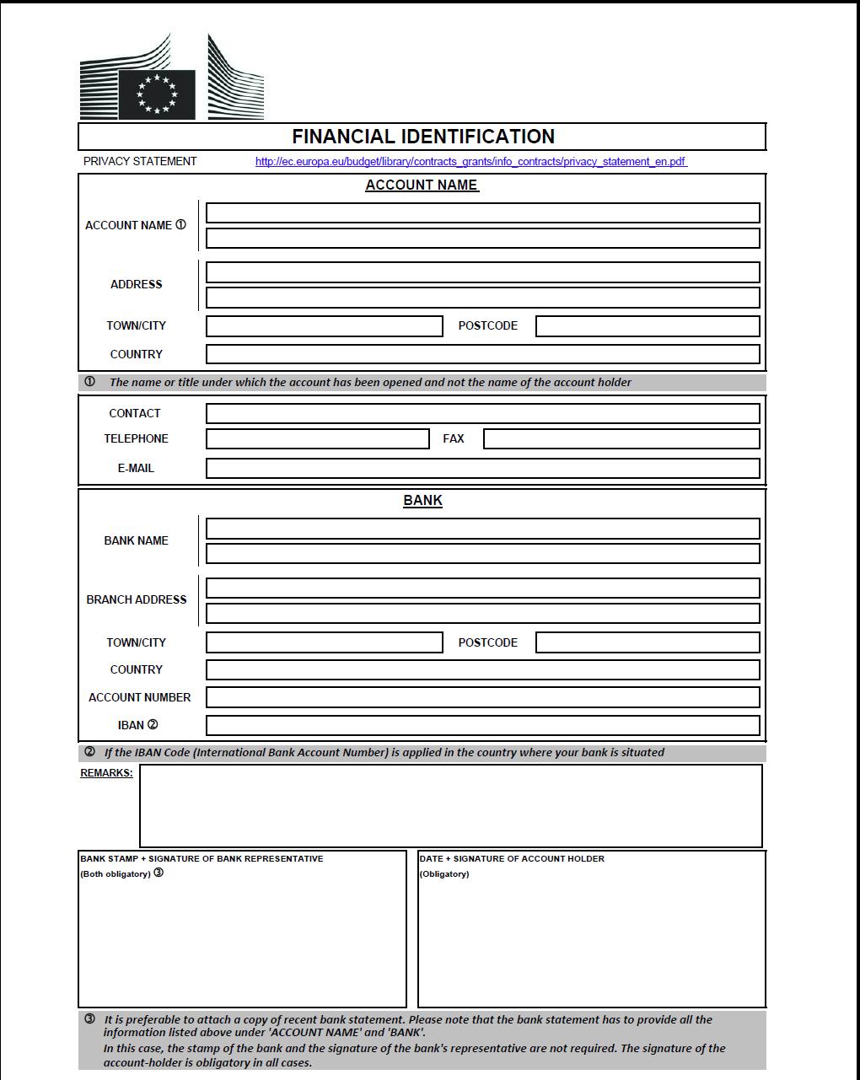

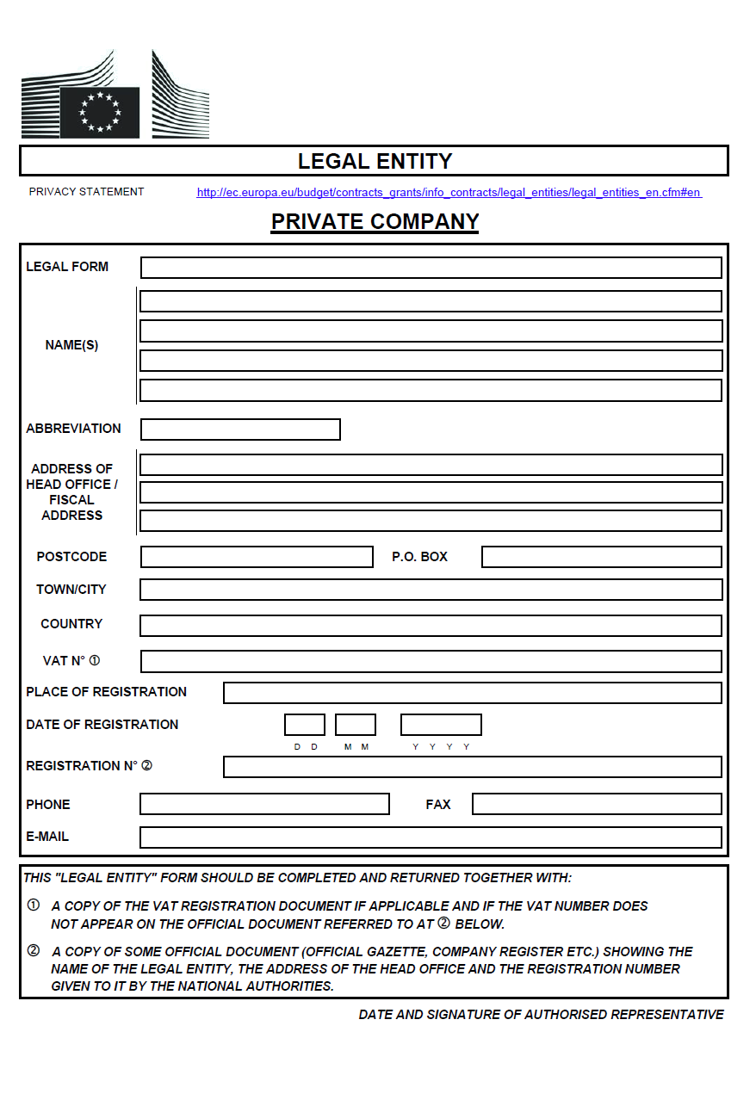

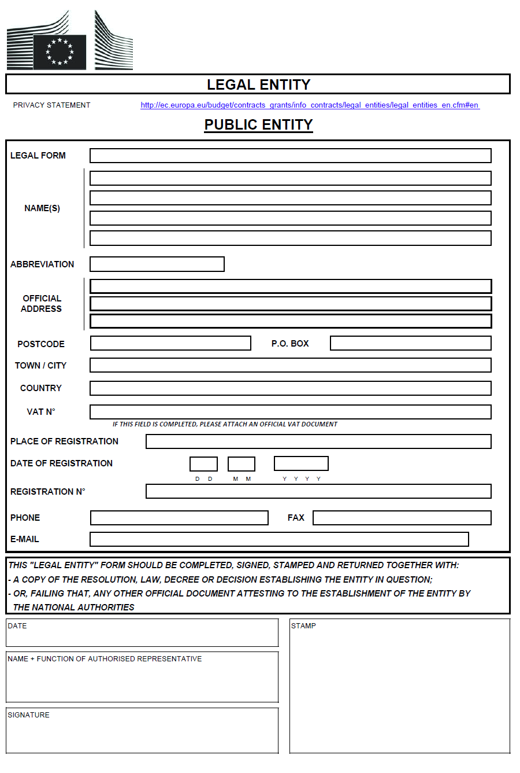

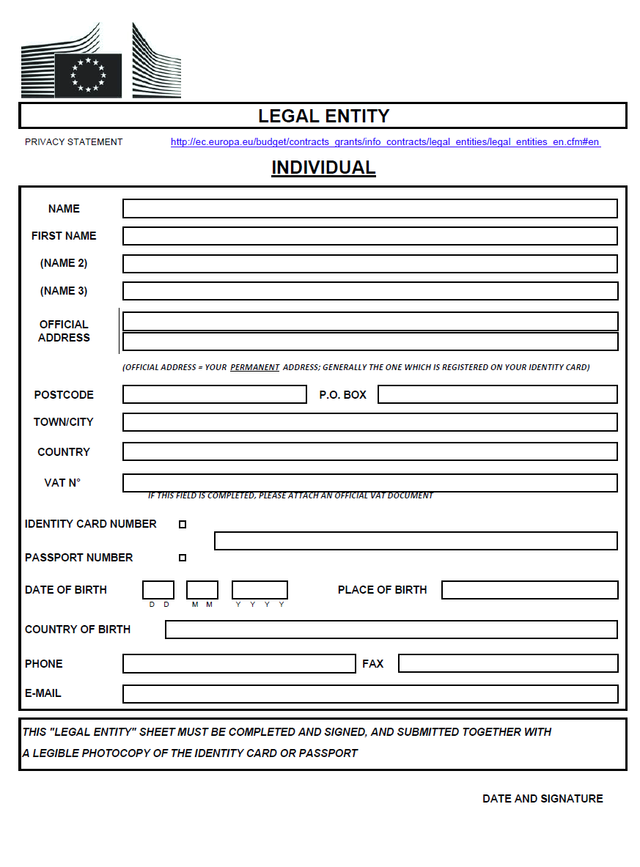

PART C. ANNEX I: Administrative compliance grid
Contract title: | Restaurant/Cafeteria Services for EULEX Mission Head Quarters Pristina | Publication reference: | RFP/5/2014/Restaurant/Cafeteria Services for EULEX Mission Head Quarters Pristina

Tender envelope number | Tenderer name | Tender submission form duly completed?  (Yes/No) | Tenderer’s declaration (signed by each consortium member, if appropriate)?  (Yes/No) | Language as required? | Organisation & methodology exists? | Key experts (list + CV)? | Key experts are present in only one tender as key experts? | All key experts have signed statements of exclusivity & availability? | Sub-contracting statement acceptable?  (Yes/No/ Not Applicable) | Nationality of sub-contractors eligible?  (Yes/No) | Overall decision?  (Accept / Reject)
1
2
....

Chairperson’s name
Chairperson’s signature
Date

PART C Annex II: TECHNICAL EVALUATION GRID

PART D: Service Tender submission form

Ref: RFP/5/2014/Restaurant/Cafeteria Services for EULEX Mission Head Quarters Pristina.
Please supply one signed tender submission form (including signed statements of exclusivity and availability from all key experts proposed, a completed financial identification form and a completed legal entity file (only for the Leader) and declarations from the Leader and all members (if you are in a consortium), together with three copies. The attachments to this submission form (i.e. declarations, statements, proofs) may be in original or copy. If copies are submitted, the originals must be dispatched to the Contracting Authority upon request. For economical and ecological reasons, we strongly recommend that you submit your files on paper (no plastic folders or dividers). We also suggest you use double-sided printing as much as possible.
Tenders submitted by consortiums (i.e., either a permanent, legally-established grouping or a grouping constituted informally for a specific tender procedure) must follow the instructions applicable to the consortium leader and its members.
- SUBMITTED by (i.e. the identity of the Tenderer)
Name(s) and address(es) of legal entity or entities submitting this tender
Leader
Member
Etc …
- CONTACT PERSON (for this tender)
Name
Organization
Address
Telephone
Fax
e-mail

- DECLARATION(S)
As part of its tender, each legal entity identified under point 1 of this form, including every consortium member, must submit a signed declaration using the attached format.
- STATEMENT
I, the undersigned, being the authorized signatory of the above tenderer (including all consortium members, in the case of a consortium), hereby declare that we have examined and accept without reserve or restriction the entire contents of the tender dossier for the tender procedure referred to above. We offer to provide the services requested in the tender dossier on the basis of the following documents, which comprise our Technical offer and our Financial offer, sealed envelope:

- Organization & Methodology
- Key experts (comprising a list of the key experts and their CVs)
- Tenderer's declaration (including one from every consortium member, in the case of a consortium)
- Statements of exclusivity and availability signed by each of the key experts
- Completed financial identification form (see Annex VI to the draft contract) providing details of the bank account into which payments under the proposed contract should be made in the event that we are awarded the contract (or the financial identification number or a copy of the financial identification form provided to the Contracting Authority on an earlier occasion, unless it has changed in the meantime)
- Completed legal entity file (or the legal entity number allocated. Alternatively a copy of the legal entity file provided to the Contracting Authority on an earlier occasion, unless the legal status has changed in the meantime)
- Duly authorised signature: an official document (statutes, power of attorney, notary statement, etc.) proving that the person who signs on behalf of the company/joint venture/consortium is duly authorised to do so.
- Documentary proof or statements required under the law of the country where we are established (or each of the companies in case of a consortium), to show that we do not fall into any of the exclusion situations listed in Section 2.3.3 of the Practical Guide to contract procedures for EU external actions. This evidence or these documents or statements must carry a date, which is not more than one year before the date of submission of the tender. In addition, a statement is furnished stating that the situations described in these documents have not changed since then.
We recognize that our tender will be excluded if we propose key experts who have been involved in preparing this project or engage such personnel as advisers in the preparation of our tender.
We are fully aware that, in the case of a consortium, the composition of the consortium cannot be modified in the course of the tender procedure, unless the Contracting Authority gives its prior approval in writing. We are also aware that the consortium members would have joint and several liability towards the Contracting Authority concerning participation in both the above tender procedure and any contract awarded to us as a result of it.
This tender is subject to acceptance within the validity period stipulated in clause 6 of the Instructions to tenderers. Signed on behalf of the tenderer:

Name
Signature
Date

FORMAT OF THE DECLARATION REFERRED TO IN POINT 3
OF THE TENDER SUBMISSION FORM
to be submitted on the headed notepaper of the legal entity concerned
<Date>

Bernd Borchardt, Head of EULEX Kosovo, and address at EULEX KOSOVO, Ndërtesa Farmed, Lagjja e Spitalit, “Muharrem Fejza”p.n., 10000 Pristina-Kosovo

Your ref: RFP/5/2014/Restaurant/Cafeteria Services for EULEX Mission Head Quarters Pristina

Dear Sir/Madam

TENDERER'S DECLARATION
In response to your letter of invitation to tender for the above contract, we <Name(s) of legal entity or entities> hereby declare that we:
- are submitting this tender < on an individual basis * / as member of the consortium led by < name of the leader / ourselves > * for this contract. We confirm that we are not participating in any other tender for the same contract, whatever the form of the application (as a member - including leader - in a consortium or as an individual Candidate);
- reconfirm that we are not in any of the situations excluding us from participating in contracts which are listed in Section 2.3.3 of the Practical Guide to contract procedures for EC external actions; ]
- agree to abide by the ethics clauses in Section 2.4.14 of the Practical Guide to contract procedures for EC external actions and, in particular, have no conflict of interests or any equivalent relation in that respect with other short-listed candidates or other parties in the tender procedure at the time of the submission of this tender;
- and have only included data in the application form concerning the resources and experience of our legal entity;
- will inform the Contracting Authority immediately if there is any change in the above circumstances at any stage during the tender procedure or during the implementation of the tasks;
- fully recognize and accept that we may be excluded from tender procedures and contract, in accordance with the Section 2.3.4 of the Practical Guide to contract procedures for EC external actions, for a maximum period of 5 years from the date on which the infringement is established and up to 10 years in the event of a repeated offence within the 5 years of the above-mentioned date. Furthermore, we acknowledge that, should we made false declarations, committed substantial errors, irregularities or fraud, we shall also be subject to financial penalties representing 2 % to 10 % of the total estimated value of the contract being awarded. This rate may be increased to 4% to 20% in the event of a repeat offence within 5 years of the first infringement;
- are aware that, for the purposes of safeguarding the financial interests of the Communities, our personal data may be transferred to internal audit services, to the European Court of Auditors, to the Financial Irregularities Panel or to the European Anti-Fraud Office.
We understand that our tender and the expert may be excluded if we propose the same key expert as another tenderer or if we propose a key expert who is engaged in an EU/EDF financed project if the input from his/her position in that contract could be required on the same dates as his/her work under this contract.
[* Delete as applicable]
We understand that if we fail to respond within the delay after receiving the notification of award, or if the information provided is proved false, the award may be considered null and void.
Yours faithfully,

<Signature of authorised representative of the legal entity >

< Name and position of authorised representative of the legal entity >

Statement of exclusivity and availability

Publication ref: RFP/5/2014/Restaurant/Cafeteria Services for EULEX Mission Head Quarters Pristina

I, the undersigned, hereby declare that I agree to participate exclusively with the tenderer < tenderer name > in the above-mentioned service tender procedure. This includes that I will not be proposed as a replacement expert in this tender procedure. I declare that I am able and willing to work for the period(s) set for the position for which my CV has been included if this tender is successful, namely:

From | To | Availability
< start of period 1 > | < end of period 1 > | < full time/part time >
< start of period 2 > | < end of period 2 > | < full time/part time >
< etc. >

I confirm that I do not have a confirmed engagement as key expert in another EU/EDF-funded project, or any other professional activity incompatible in terms of capacity and timing with the above engagements.
By making this declaration, I understand that I am not allowed to offer my services as an expert to any other tenderer participating in this tender procedure. I am fully aware that if I do so, I will be excluded from this tender procedure, the tenders will be rejected, and I may also be subject to exclusion from other tender procedures and contracts funded by the EU/EDF.

I also declare that I am not in a situation of conflict of interest or unavailability and commit to inform the tenderer(s) of any change in my situation.
I acknowledge that I have no contractual relations with the Contracting Authority and in case of dispute concerning my contract with the Contractor I shall address myself to the latter and/or to the competent jurisdictions.
[For information, I have signed a Statement of Exclusivity and Availability for the following tender(s):

Tender reference | Submission deadline for the tender | Tendered engagement
< tender reference > | < date > | < full time/part time >
< tender reference > | < date > | < full time/part time >
< etc. >

Should I receive a confirmed engagement I declare that I will accept the first engagement offered to me chronologically. Furthermore I will notify the tenderer immediately of my unavailability. ]

Name
Signature
Date

Participation is open to legal persons which are established in a Member State of the European Union, in an official candidate country or a country that is a beneficiary of the Instrument for Pre-Accession Assistance, in a Member State of the European Economic Area, a country of the Western Balkans region or a contributing third State, as authorized by Council Joint Action 2008/124/CFSP of 04 February 2008 on EULEX KOSOVO.
Where the contracting party is an individual.
Where applicable. For individuals, mention their ID card or passport or equivalent document - number
Except where the contracting party is not VAT registered.
The EULEX Kosovo) is a diplomatic mission and according to UNMIK Executive Decision No 2008/36 of 9 December 2008, it is granted exemption from all customs duties, taxes, and related charges other than charges for storage, cartage and similar services, on articles for its official use.
The Contracting Authority reserves the right to contact the reference persons. If you can not provide a reference, please provide a justification.
add/delete additional lines for consortium members as appropriate. Note that a sub-contractor is not considered to be a consortium member. If this tender is being submitted by an individual legal entity, the name of that legal entity should be entered as 'Leader' (and all other lines should be deleted). Any change in the identity of the Leader and/or any consortium members between the deadline for receipt of tenders indicated in the Instructions to tenderers and the award of the contract is not permitted without the prior approval in writing of the Contracting Authority.
To be completed by all key experts for which such a declaration is required in the Terms of Reference.
The engagement of an expert is confirmed if the expert is committed to work as a key expert under a signed contract financed by the EU general budget or the EDF or if he/she is a key expert in a tender which has received a notification of award. The date of confirmation of the engagement in the latter case is that of the notification of award to the Contractor.

